**PROJECT TITLE: HALL MANAGEMENT SYSTEM**

**1. INTRODUCTION**

**1.1 Purpose**  
The purpose of developing this “HALL MANAGEMENT SYSTEM” is to keep the owner of halls and their clients connected through a platform where the deal can be done (Hall can be booked) even when they cannot reach to the physical platform. This means that they can easily do this anywhere if they have this system.

**1.2 Document Conventions**

This Document was created based on the IEEE template for System Requirement Specification Documents.

**1.3 Intended Audience and Reading Suggestions**

* Designers looking for event management
* Caterers expanding their business
* Business entrepreneurs holding seminars or meetings

**1.4 Product Scope**

Hall Management System is a service catering mainly to users looking to expand their business and manage it efficiently without much hassles. This provides a friendly and smooth interface with the use of its convenience tools that allow for a wide range of customizations at the touch of a button. This is all dependent on user preference and targets them accordingly. Whether it be a business meeting, seminar, a social gathering or an event, there is an endless amount of customizations.

**1.5 References**

<https://www.freeprojectz.com/c-projects-projects/c-project-hall-booking-system>

https://www.thecrazyprogrammer.com/2012/12/c-hotel-management-project.html

<https://www.youtube.com/watch?v=o8E7bnBql40>

**2. OVERALL DESCRIPTION**

**2.1 Product Perspective**

Hall Management system was created with managing all information about Booking Dates, Inventory, Customers, and Booking Dates. The project is totally built at administrative end and thus only the administrator is guaranteed access. The purpose of this project is to reduce the manual work for management all the while keeping track of all records and data.

**2.2 Product Functions**

As the hall management system is one that aims to give the user an experience equal to or better than sort they would find in a traditional booking office.

The system after careful analysis has been identified to be presented with the following functionalities:

* Client Registration: Client can sign up to create his account.
* Record Client Storage: The client information files should be stored in separate database which can be maintained by the system.
* View Availability Of Halls: Client can look for his desired hall by five filters:
* Location
* Price range
* Specific Date availability
* Seating capacity
* View all Halls
* Hall Registration: Hall owner can sign up to create his hall account.
* Record Hall Storage: The hall information files should be stored in separate database which can be maintained by the system.
* Confirmation: Confirmation of this booking will be provided by hall owner if payment is done by client.
* Administration Access: Administration would be able to keep an eye on the records of clients.

**2.3 User Classes and Characteristics**

To implement the system according to the real mechanism of bookings following classes were made:

* User: That includes user credentials and is a basic sign up and log in for the end customer to search halls for bookings using available filters. User can also check his bookings.
* Hall: That includes hall’s credentials and creates an account for it to register it in the halls record. Hall can also check its bookings.
* Time: That keeps records of the scheduled bookings of all the registered halls so it is easy to keep track of bookings.
* Bookreq: That includes search filters and all info according to which customer can request a booking to the hall owner if that is vacant for the requested time and date. The hall owner then confirms the booking and the user is sent a message of confirmation of booking.

**2.4 Operating Environment**

* Windows 2000
* Windows XP
* Windows Vista
* Windows 7
* Windows 8
* Windows 10
* Mac OS X
* Linux

**2.5 Design and Implementation Restraints**

This is developed in C++ using Visual Studio as its IDE. Using only the base libraries such as Iostream, fstream as well as vector. The environment is upheld in webpage using HTML showing the output.

**3. EXTERNAL INTERFACE REQUIREMENT**

**3.1 User Interfaces**

1. WELCOME SCREEN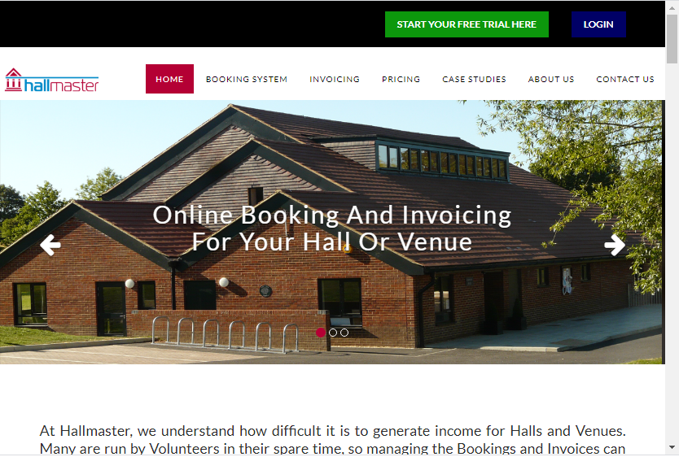

**2. BOOKING MAINSCREEN**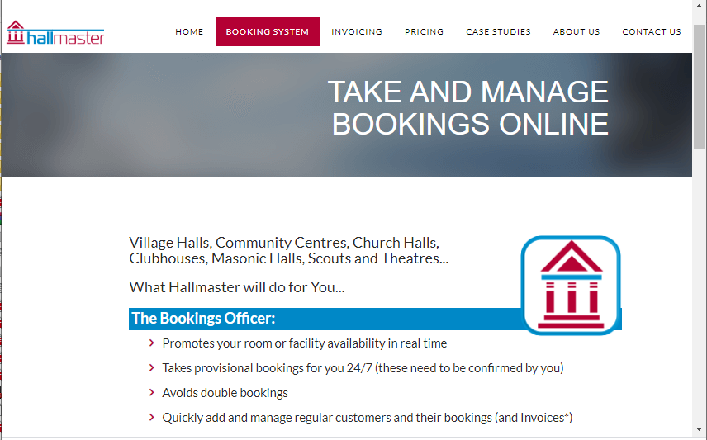

**3. LICENSE PRICING SCREEN**

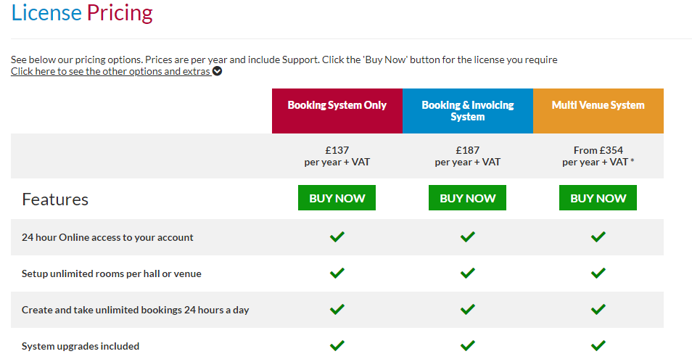

**3. INVOICING FEATUURES DISPLAY** 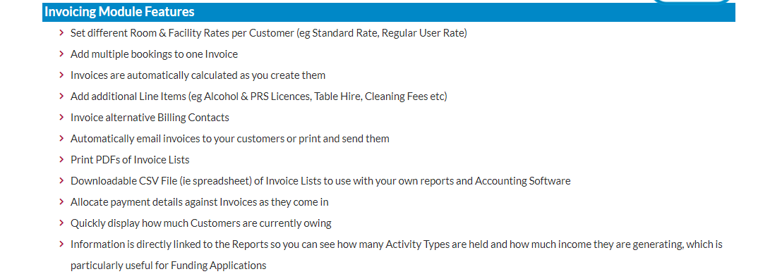

**3.2 Hardware Interfaces**

We strongly recommend a computer fewer than 5 years old.

* Processor: Minimum 1 GHz; Recommended 2GHz or more
* Ethernet connection (LAN) OR a wireless adapter (Wi-Fi)
* Hard Drive: Minimum 128 GB; Recommended 380 GB or more
* Memory (RAM): Minimum 1 GB; Recommended 4 GB or above
* Sound card w/speakers
* Some classes require a camera and microphone

**3.3 Software Interfaces**

Hall Management system website require PHP to be installed on the system. Hall Management system will be connected with a MySQL, SQLite database to maintain the pricing detail.

**3.4 Communications Interfaces**

Hall management system requires an internet connection to install new plugins, update already installed ones and update some of its components (APIs, modules etc.).

**4. SYSTEM FEATURES**

**4.1 SIGN-UP.**

**4.1.1 Description and priority**

This feature is of utmost important. Signing up gathers all data about the end user/hall owner which helps to validate their originality. This creates their account on the database of the system. This way both can navigate their functionalities and access the system to benefit from it.

**4.1.2 Stimulus/Response Sequences**

User gives stimulus to the system by opting for sign up. System then asks the user for his credentials that includes:

* For Customer/Hall owner
* Name
* Email
* Contact Number
* City
* Desired Username

The credentials which are special about the hall are:

* Hall address
* Town
* Seating capacity
* Rent per booking

Then the system asks both of the users to choose a desired a password which must include at least one number and a special character. If the requirements are fulfilled by the user then it is confirmed and assigned to the username in the database which is unique to easily identify the user otherwise error is generated and user is required to enter his password again keeping instructions intact and validated again. The system also asks user to enter desired username and is validated to check its uniqueness. If it already exists, error is generated and user is asked again to enter username and verified again. This way, the user is registered in the database of the system.

If all the requirements are provided by the user and are correct, so the user I sent a code via SMS to enter it in the system to confirm and finalize his account sign up.

**4.1.3 Functional Requirements**

For this feature to execute efficiently, Users must have a

1. Unique contact no.
2. A unique username

so that only s/he is able to access his/her account. If this uniqueness exists then his account is added to database of the system. This way the system registers new customers/hall owners.

**4.2 LOG-IN.**

**4.2.1 Description and priority**

To begin with the system login is the key.

**4.2.2 Stimulus/Response Sequences**

User gives stimulus to the system by opting for Login. The system in response directs the user/hall owner to the login screen. Both the User and Hall owner have separate login screens which opens up by opting for them respectively.

After being directed to the login screen, system stimulates the user to enter his login credentials in response to which the user must enter valid credentials. The following credentials are needed which are same for user and the hall owner:

* Username
* Password

If the credentials entered are not correct the system shows an error for the invalid username or invalid password and the user is again asked to enter the said credentials and validated again. If the credentials are correct, the login screen disappears and the user is given access to his account.

**4.2.3 Functional Requirements**

For the Login to execute efficiently, Users must have a

1. Valid Username
2. Valid Password

So that s/he is directed to their account in no time thus saving the time to resolve the errors which may rise up due to invalid username/password.

**4.3 BOOKING.**

**4.3.1 Description and priority**

This feature is the very founder and basis of this system. This feature automates the official booking process of the halls both for the customers and the hall owners, thus connecting both the customer and the hall owners through their accounts. Booking criteria is easily understood by the customer the way it is developed as it contains five major search filters so the customer can easily find the hall according to his needs. This feature informs the customer about the availability of halls, thus saving time of the hall owner to tell the customer about the clashes in the timings and any previous bookings of the hall. The customer can lodge a booking request which is then confirmed by the hall owner. After payment is done by the customer, the hall is booked for the particular customer for the particular event and date/time. The customer can then check his bookings on his account.

**4.3.2 Stimulus/Response Sequences**

User gives stimulus to the system by opting for booking. The system in response directs the customer to the booking page where the customer can search for the halls by the following search filters:

1. Location

If the customer opts for location, then he is asked for the city if he wants to book the hall in another city other than where he lives otherwise his current location is used by system. Then the user can choose from the displayed locations of halls in that city or can enter his location for the hall. Once the location is confirmed, all registered halls in the system of that particular location are displayed to the user.

2. Price Range

If the customer opts for price range, the system in response asks the customer about his budget range. After the customer enters his budget range, the system in response displays all the halls that comes in his budget range so the customer can choose from all the listed halls the one that is most feasible to him.

3. Specific Date Availability

If the customer opts for this filter, the system in response asks the customer about the date on which he wants to book hall. When customer enters his date, the system displays all the halls that are available on that specific date. The customer then can choose any hall from them and lodge booking request.

4. Seating Capacity

If the customer opts for this filter, the system in response asks the customer about the range of expected guests of the customer. After customer enters his number of expected guests, the system displays all the hall that come in that range capacity. The customer can then choose from the listed halls that is feasible to him.

5. View All Halls

If the customer opts for this filter, the system displays all the halls that are registered in the system.

**N.B.:** The customer can also use the first four filters at the same time to save his time to directly narrow down his options to his specific needs.

After the Customer chooses his desired hall using any of the or all of the filters, he can lodge a booking request to the hall by clicking the book button where he is to provide details of his booking that includes:

* Date
* Time
* Seating Capacity
* Duration of Event
* Additional details (optional)

After he provides all the details and confirms his decision of booking, the request goes to the hall owner. The hall owner from his account sees customer’s request and contacts him for his confirmation. After this, the customer’s request is accepted by the hall owner and customer is asked to pay in advance some amount to confirm his booking. After the customer pays some amount in advance, it is validated by the hall owner and the hall is booked for the customer and a receipt of booking confirmation and details is sent to customer’s account. And the booking is done.

**4.3.3 Functional Requirements**

For this feature to execute efficiently, Users must

1. Sign up to the system
2. Log in the system
3. Choose the hall
4. Provide details for booking
5. Lodge request to the hall owner
6. Pay to hall owner via master card, visa etc.
7. Confirm the booking ( hall owner )

So that the process is smooth and both can benefit from the core feature of this system which is the sole purpose of this system.

**5. OTHER NON FUNCTIONAL REQUIREMENTS**

**5.1 Performance Requirements**

* **Secure access of confidential data (user’s details).**
* **Maximum time availability.**
* **Better component design to get efficiency at peak time.**
* **Flexible service based architecture will be highly desirable for future extension.**
* **Exception Handling**

**5.2 Safety Requirements**

User should ensure that backups of all data is made beforehand. It should be kept in mind that data should be well documented as well as backed up regularly to avoid any mishaps.

Response time should be measured to be accurate.